MilConnect
https://www.dmdc.osd.mil/milconnect
Version 2.4
December 6, 2012

This guide outlines the procedures for logging into MilConnect
and updating user information. Changes made in MilConnect will
facilitate GAL updates, user moves, and customer education.

Logging into MilConnect
- Log into https://www.dmdc.osd.mil/milconnect
a. MilConnect Login page:
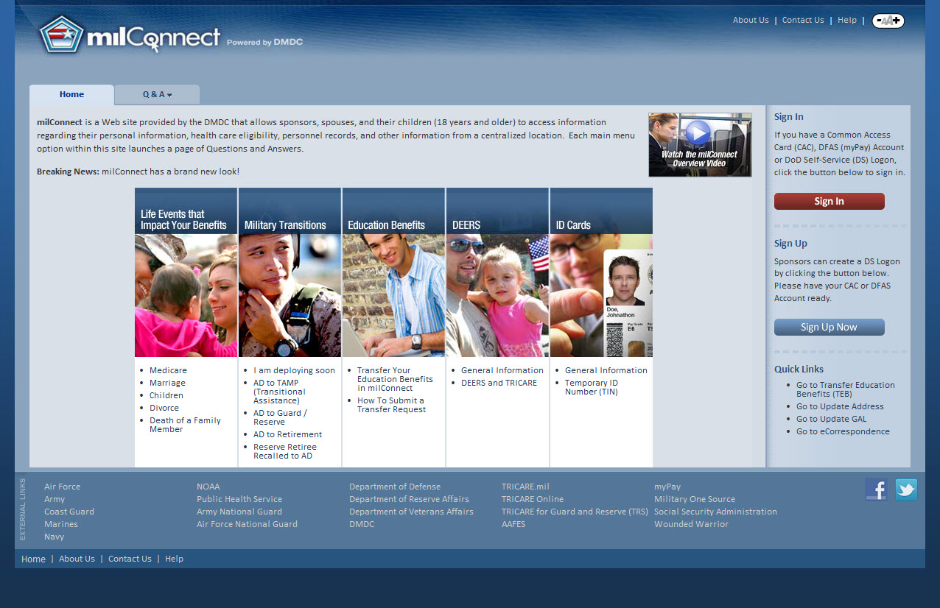
- Select Sign In
- Select OK on the Banner page
  - Banner Page:
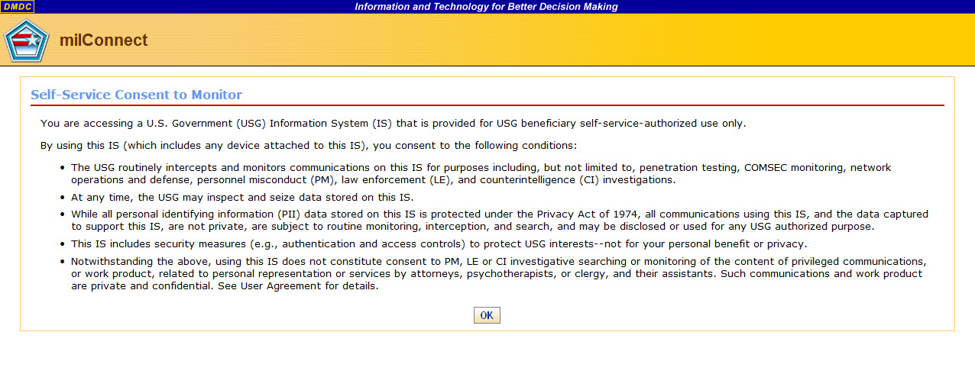

- On the next page, select the CAC tab and “login” and select the email cert when the dialog prompts for certificates.
  - The MilConnect Logon method
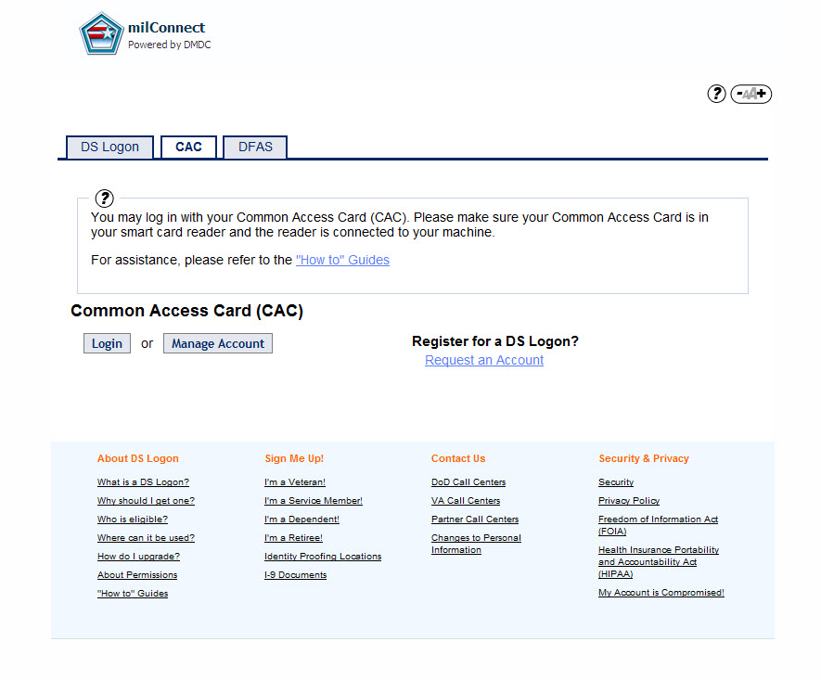

Under your personal MilConnect homepage:
- On your personal MilConnect Screen, there are a few options for updating GAL info:
  - Personal MilConnect Screen
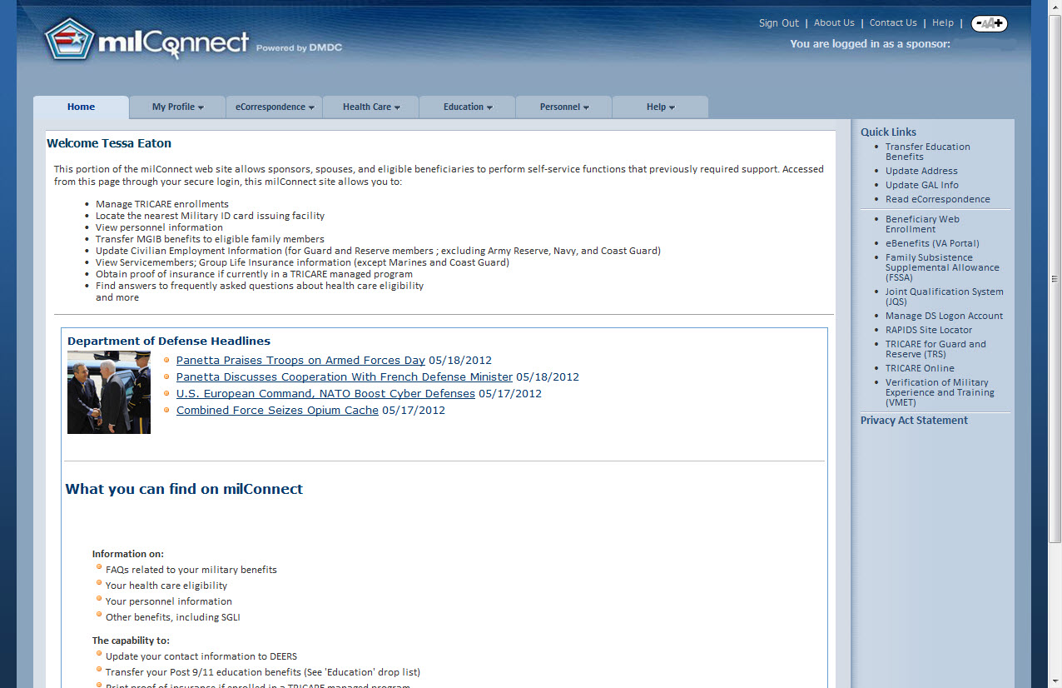

- To update GAL Info, such as Name information and Duty Installation, select “Update GAL Info” on the right navigation panel.
a. Update Name information:
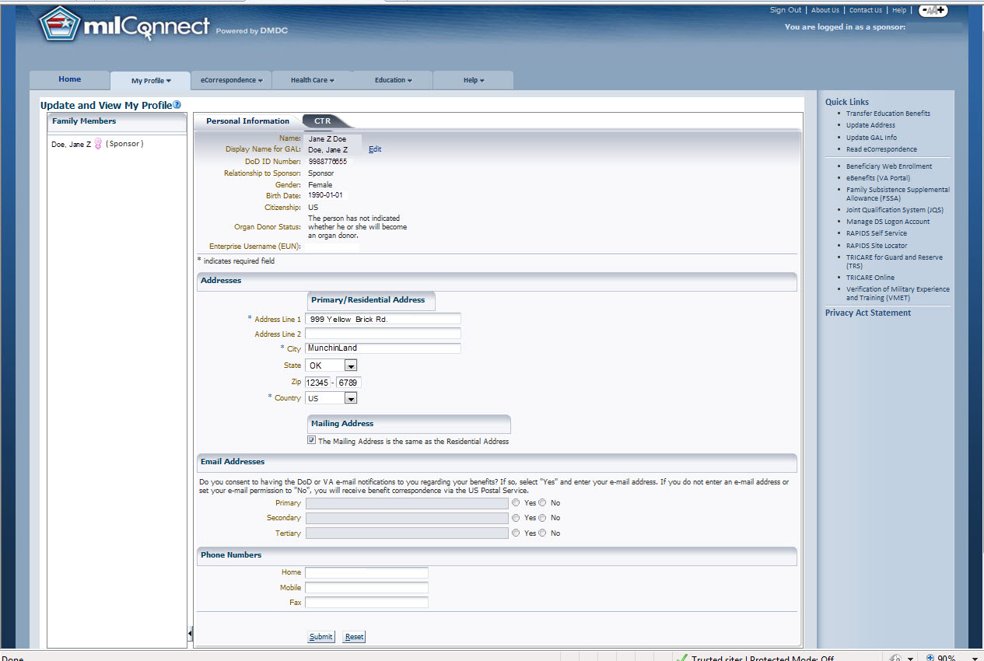
Personal Addresses and phone numbers are not sent to Enterprise Email.
Your account information will appear here. Note, there is a limited amount of information that is editable. For example, to change your legal last name you will need to see your Personnel Management Office
b. Update Duty Installation :
(Please note that updating the Duty Installation Field could trigger a mailbox move within 24 hours of an update)
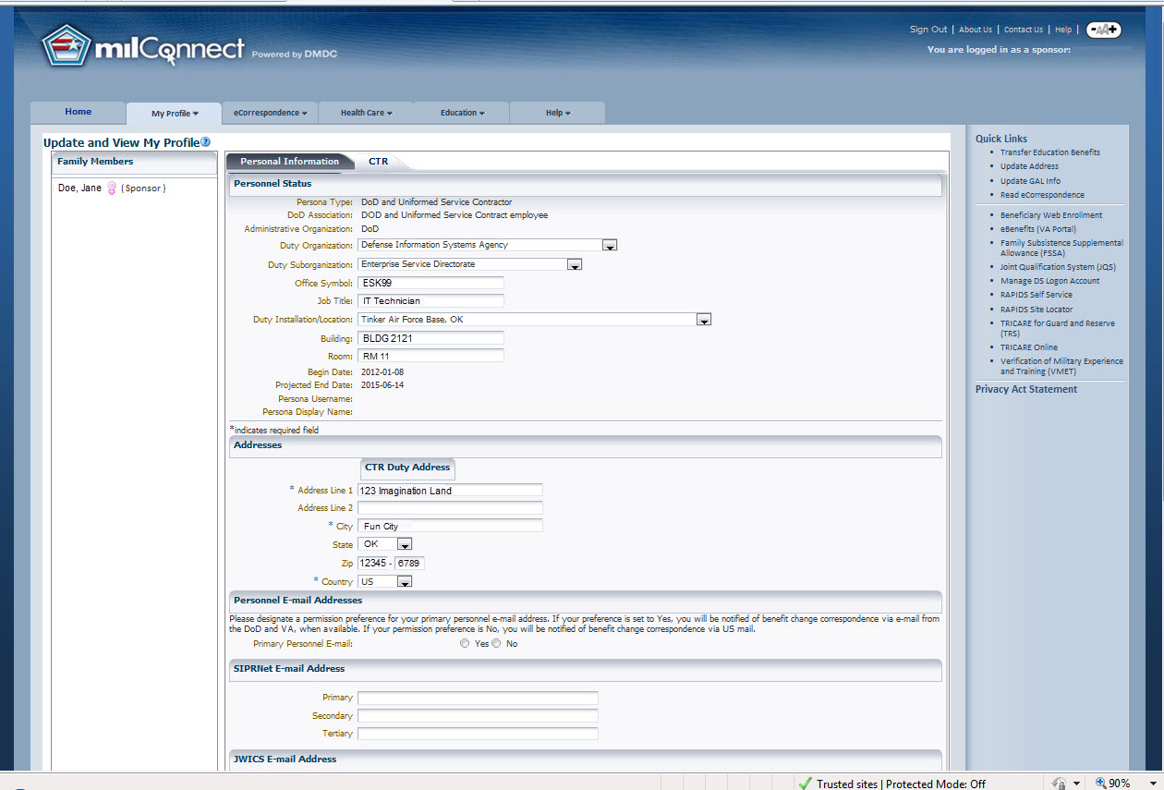
Note, changing the Duty Installation field will trigger a mailbox move within 24 hours.

Under the Update Address Link:
- There are two tabs listed under the Update Address section, Personal Information and DoD Information. This information is used only for your personal account. To update GAL address information, update the information under the Persona Type Tab (MIL, CIV, CTR, etc)
  - Update Address, Personal Information Section:
Note, the only thing sent to the GAL on this page is the Display Name for GAL.
Residential Addresses are not sent to Enterprise Email.
  - Update Address, Duty Address Section for PTC
CTR Page continues BELOW
This section updates the core of the user’s contact information in the Enterprise Email GAL.

Under the Update Address Link:
- Under the PTC Tab, at the bottom of the page, users can update their phone numbers for the GAL.
  - Update Phone Numbers, PTC Section:
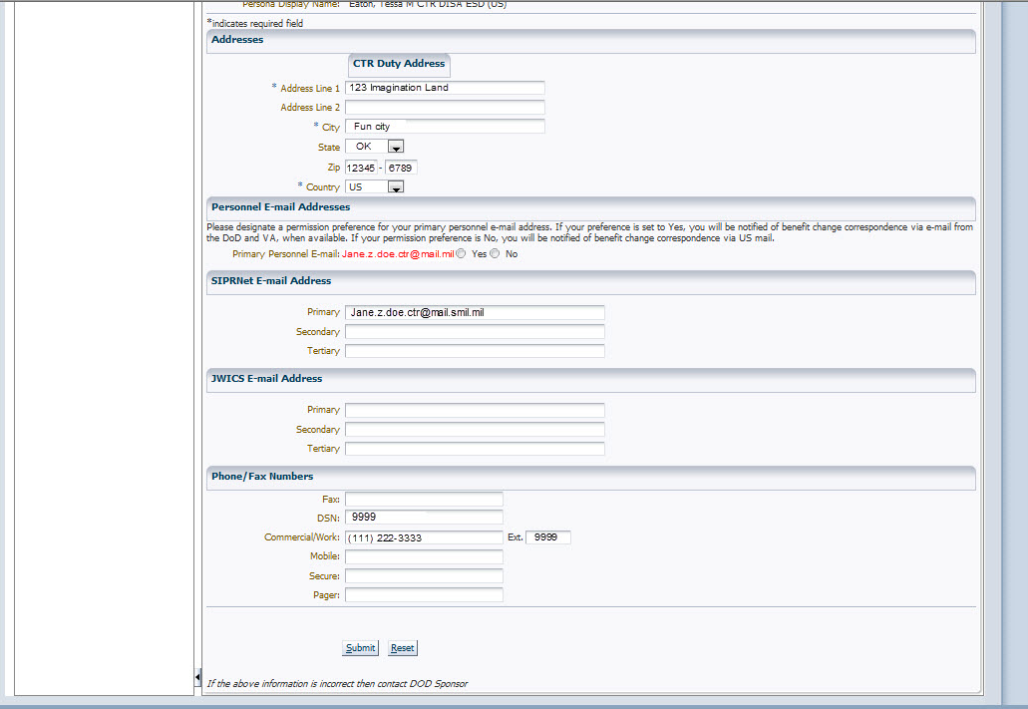
CTR Page continuation
Phone numbers can be updated here.

Example GAL Entry:
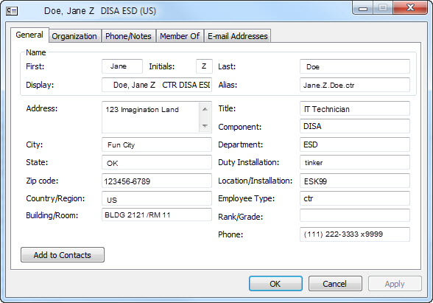

Under the Update Address Link:
- The table below lists the user GAL fields and how to update them
  - Table of GAL Fields
GAL Field | Comment | If updatable, this is where they would do it at:
Name (first, m, last) | can be updated at: | Personnel Office/HR system. (MilConnect has limited name options under Update GAL Info)
Alias | cannot be changed, no matter what
Display | Is a combination of fields in MilConnect/DMDC
Address | can be updated at: | MilConnect (under Update Address> PTC tab>Duty Address)
City | can be updated at: | MilConnect (under Update Address> PTC tab>Duty Address)
State | can be updated at: | MilConnect (under Update Address> PTC tab>Duty Address)
Zip Code | can be updated at: | MilConnect (under Update Address> PTC tab>Duty Address)
Country | can be updated at: | MilConnect (under Update Address> PTC tab>Duty Address)
Title | can be updated at: | MilConnect (Under Update GAL Info>PTC tab> Job Title)
Component | can be updated at: | MilConnect (Under Update GAL Info>PTC tab> Duty Organization)
Department | can be updated at: | MilConnect (Under Update GAL Info>PTC tab> Duty Sub Organization)
Location  (OA, Office Symbol in OWA) | can be updated at: | MilConnect (Under Update GAL Info>PTC tab>Office Symbol
Assistant | This field is not used at all.
Employee Type | can be updated by getting a new CAC.
Rank/Grade | can be updated by getting a new CAC.
Phone | can be updated at: | MilConnect (under Update Address>PTC tab> Phone/fax section)
Location of mailbox or change which address list they fall under. | can be updated at: | MilConnect (Under Update GAL Info>PTC tab> Duty Installation)  and /or MilConnect (Under Update GAL Info>PTC tab> Duty Organization) combination
Please note that these can, and probably will change in the future. We will try to keep you updated as well as we can. If the users still cannot get their information updated correctly, Tier III needs the following to troubleshoot: 1.) the date/time they last updated MilConnect 2.) screenshots of MilConnect (the information they are trying to update) 3.) the correct information is needed as well.

