Accessing EUCOM NIPR over Web VDI Services

Overview
This document covers prerequisites and procedures for accessing EUCOM NIPR over Web (NoW) VDI services
Revision History

Version | Date | Change History | Author
1.0 | 6 Sep 2018 | Initial | TL
1.1 | 6 Sep 2018 | Minor edits not affecting the content | BJF
1.2 | 6 Sep 2018 | Added Windows OS as a prerequisite. Added how to download from IASE | TL
1.3 | 1 May 2019 | Update Delivery pool name and renamed Citrix Receiver | TL
2.0 | 16 Mar 2020 | Updated InstallRoot instructions, added Entrust instructions, updated Citrix Workspace App instructions | MAD
3.0 | 06 Oct 2020 | Updated links for InstallRoot and revised/relocated instructions, updated Entrust certificate links, and included G+D FIPS card log in instructions | EJF
3.1 | 21 Jan 2021 | Updated certificate selection for Citrix login to Authentication/ID | EJF

Table of Contents
Contents
Prerequisites 1
Install DoD InstallRoot 2
Install Entrust Certificates 4
Install Citrix Workspace App 5
Connecting to EUCOM NIPR over Web 6

Prerequisites

- Current release of DoD InstallRoot
- Entrust G2 and L1K Certificates
- Current release of Citrix Workspace App
- Microsoft supported version of Windows 10 found here (in the End of service: Home… column):
https://docs.microsoft.com/en-us/windows/release-information/

Install DoD InstallRoot

- Click the Start Menu
- Type About your PC and then select the one that says System Settings beneath it

Note: If you do not see this choice, click the gears icon in the Start Menu, click the System icon, and then click About in the left-hand navigation pane

- Under Device Specification, look for the System type entry and use that text to determine which file to download in the next step

- Download the latest version of DoD InstallRoot NIPR Windows installer file from the steps below

- Browse to https://public.cyber.mil
- Click on PKI/PKE in the top-right navigation bar
- Click on Public Key Infrastructure/Enabled (PKI/PKE)
- In the left-hand navigation pane, locate and click on Tools
- In the middle pane, locate and click on either the 32-bit or 64-bit InstallRoot Windows Installer

Note: You should not need the Non-Administrator installer

- Launch the installer
- Click Next to continue
- Leave the default file location and click Next
- Select only the Graphical Interface and uncheck other features
- Once the install completes, click Run InstallRoot to launch the program
- When prompted for managing JAVA certificate store, click No to continue

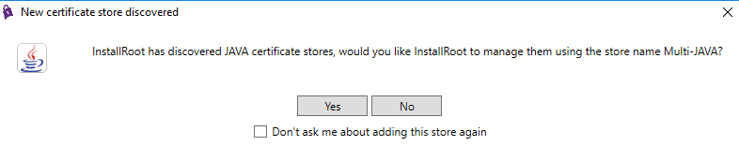

- Close the Quick Start window
- Ensure Install DoD Certificates is checked

- Locate and click Install Certificates
- Wait for certificates to install. Monitor the progress screen shown below for any errors

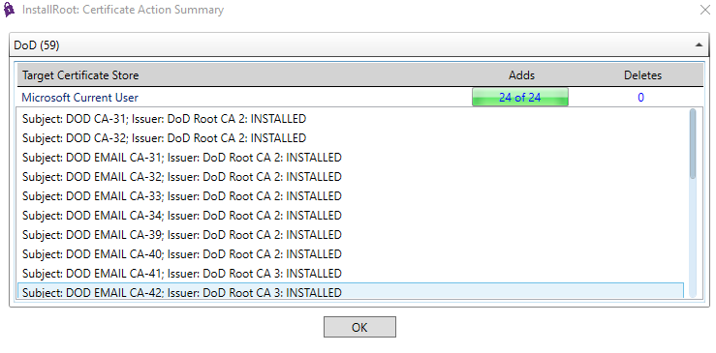

- If the certificates are successfully installed, you should see checkmarks under the Installed column

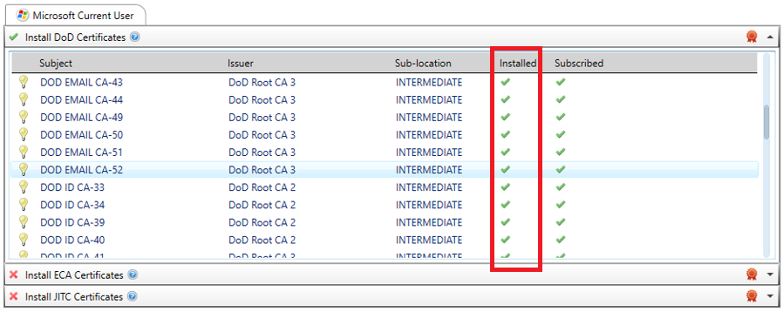

Install Entrust Certificates

- Copy and paste the following URL in your browser:

https://web.entrust.com/root-certificates/entrust_g2_ca.cer

- If prompted, select where you want to save the file (annotate where the file is saved to)
- Press <Win><R> (or right-click the Start Menu and select "Run"), type certmgr.msc and then press <Enter>
- In the left-hand pane, expand Certificates - Current User and then expand Trusted Root Certification Authorities
- Right-click on Certificates, click All Tasks, and then click Import
- Click Next and then click Browse
- Navigate to the file you downloaded in step 2 and then select entrust_g2_ca.cer and click Open
- Click Next twice and then click Finish
- When prompted, click OK
- In the left-hand pane, under Trusted Root Certification Authorities, click on the Certificates folder
- In the right-hand pane, scroll down and verify that Entrust Root Certification Authority - G2 is listed

Note: Leave this window open while you perform the following steps

- Copy and paste the following URL in your browser:

https://web.entrust.com/root-certificates/entrust_l1k.cer

- If prompted, select where you want to save the file (annotate where the file is saved to)
- Switch back to the certmgr.msc window you were working in previously
- In the left-hand pane, expand Certificates - Current User and then expand Intermediate Certification Authorities
- Right-click on Certificates, click All Tasks, and then click Import
- Click Next and then click Browse
- Navigate to the file you downloaded in step 13 and then select entrust_l1k.cer and click Open
- Click Next twice and then click Finish
- When prompted, click OK
- In the left-hand pane, under Intermediate Certification Authorities, click on the Certificates folder
- In the right-hand pane, scroll down and verify that Entrust Certification Authority - L1K is listed

Install Citrix Workspace App

- Download the latest Citrix Workspace App client (not beta or tech preview versions) from:

https://www.citrix.com/downloads/workspace-app

- Once the file has been downloaded, open (or run) the file
- Click Start to continue
- If you accept the license agreement, click Install

Note: If you do not accept the license agreement and click cancel, you will not be able to utilize the EUCOM NIPR over Web service

- Upon a successful install, click Finish

Connecting to EUCOM NIPR over Web

- Open your browser and navigate to https://home.eucom.mil
- Review the standard DoD consent to monitoring banner and click Accept

Note: If you do not accept the consent to monitoring, you should close your browser, but you will not be able to utilize this service

- Select your Authentication (DOD ID CA-##) certificate and click OK

Note: If your Authentication/ID certificate is not displayed, click More choices, find and select it, and then click OK

Correct - This screenshot shows Authentication/ID certificate being selected

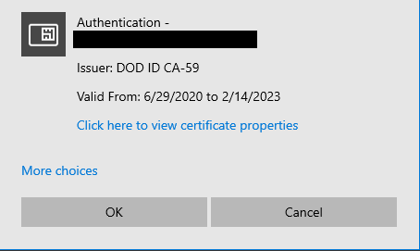

- When prompted, enter your PIN and click OK
- Once loaded, click on the DESKTOPS tab to see available VDI desktops

- Click on the monitor icon labeled as PAT-PRD, SHP-PRD, PAT-UAT, or SHP-UAT (as applicable)

- If you are prompted to do so, click Allow to permit the Citrix Systems, Inc add-on to run

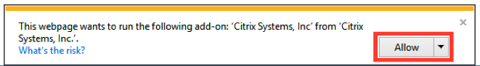

- A new window will open, connecting to your VDI session
- It may take a few minutes to transition from the Connecting window (left) into the initial EUCOM VDI session window (right)

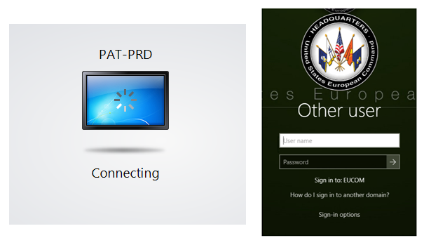

- Wait for Sign-in options link to appear and then click the Smart Card sign-in icon

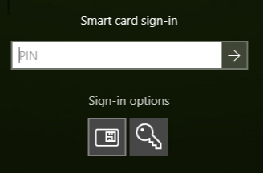

- Select the certificate icon that shows a 16-digit number (DoD ID number + 6 digits).
- Type your PIN and press <Enter>
- Your VDI desktop session will now load

